JAMBY G. REYES INFORMATION MANAGEMENT
BSIT 2F2

Exercise #9:
- List the minimum perks package.
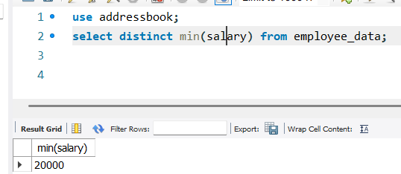

- List the maximum salary given to a “Programmer”.
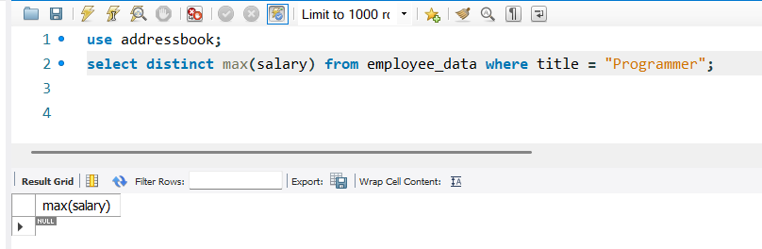

- Display the age of the oldest “Marketing Executive”
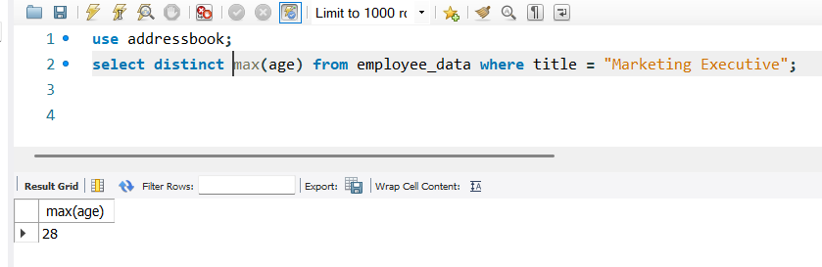
- (Tricky!) Find the first and last names of the oldest employee.
